**Type the title of your article here**

Please fill out the field above.

(bold, font size 18, centred)

Type the author’s name(s)

Type the author’s e-mail (font size 12, centred)

Please fill out the field above with a concise academic biography of the author in a formal style, including academic degrees, a short description of academic career with relevant academic functions, disciplinary research focus, current research interests, teaching focus and a general description of publication record. Three to five sentences. In case of co-authors please repeat this process.

(font size 10, centred)

**Abstract:** up to 10 lines

Please fill out the field above. A single paragraph of about 150-200 words maximum. Abstracts should give a complete overview of the work. We encourage authors to use the following style of abstracts: background, methods, results and conclusion. The abstract should give an objective representation of the article.

Font size 9, indented 1cm from the left margin and 1cm from the right margin,

**Keywords:** up to 5 words divided by comma

Please fill out the field above with your 3-5 keywords: keyword1; keyword2; keyword3, etc.

(font size 9, lower case)

**Introduction**

In this section you can present your object, subject, goals and tasks of research, your theoretical background - what approaches and methods you have used, what are your sources, what basic theories or concepts you will use.

1. **[Title of the chapter]**

In this and the following paragraphs you can structure the individual parts of your research by presenting your hypothesis, arguments, evidences, reasoning, refer to authorities or your own experimental (empirical) data. You can illustrate your presentation with tables, charts, graphs, images and more.

1. **[Title of the chapter]**

In this and the following paragraphs you can structure the individual parts of your research by presenting your hypothesis, arguments, evidences, reasoning, refer to authorities or your own experimental (empirical) data. You can illustrate your presentation with tables, charts, graphs, images and more.

**Conclusions**

Summary of research results. What are the conclusions of your study? How do they enrich existing ones? Do they confirm your working hypothesis?

**Acknowledgments**

In this section you can acknowledge any support given which is not covered by the author contribution or funding sections. This may include administrative and technical support, or donations in kind (e.g., materials used for experiments).

**Appendix**

The appendix is an optional section that can contain details and data supplemental to the main text. It can include tables, charts, graphs and more.

**References [**font size 10, left-aligned**]**

References must be arranged in alphabetical order of the first author in the Reference list and listed individually at the end of the manuscript. References must be in APA format. APA references are used in the social sciences, education, engineering and business. For more information, please see the Publication Manual of the American Psychological Association, 6th edition.

Author, A. A. (Year of publication). *Title of work.* Location: Publisher.

Author, A. A., B. B. Author. (Year of publication). Title of chapter. In: Editor, A.A., B. B. Editor, eds. *Title of book.* Location: Publisher.

Author, A. A., B.B. Author, C.C. Author. (Year of publication). Title of article. *Title of Periodical,* volume number, issue number, pages (p./ pp.).

Author, A. A., B. B. Author. (Date of publication). *Title of page.* Retrieved from link

**Single author book reference:**

Surname, Name. (Year). *Book title*. Place of publication.

Felbor, U. (1995). *Rassenbiologie und Vererbungswissenschaft in der Medizinischen Fakultät der Universität Würzburg, 1937-1945*. Würzburg.

**Books with two authors:**

Surname, Name and Name Surname. (Year). *Book title.* Place of publication.

**Books with three or more authors:**

Surname, Name / Surname, Name and Name Surname. Year. *Book title*. Place of publication.

**Publications by the same author published in the same year:**

Surname, Name. (Year a). *Title*. Place of publication.

Surname, Name. (Year b). *Title*. Place of publication.

**Edited volume by one editor:**

Surname, Name. ed. (Year). *Book title*. Place of publication.

**Edited volume by two editors:**

Surname, Name, Name Surname. eds. (Year). *Book title*. Place of publication.

**Edited volume by more than two editors:**

Surname, Name / Surname, Name, Name Surname, eds. (Year). *Book title*. Place of publication.

**Reference to a specific book chapter:**

Surname, Name. (Year). *Chapter title*. – In: Surname, Name, ed./ eds. *Book title*. Place of publication.

Williams, C. (2008). Personal Papers: Perceptions and Practices. - In: Craven, L., ed*. What are Archives? Cultural and Theoretical Perspactives. A Reader*. New York, 53-70.

**Journal article:**

Surname, Name. (Year). Article title.- *Journal title* volume (issue number), page numbers.

**Journal article / electronic source:**

Surname, Name. (Year). Article title.- *Journal title*, volume, issue number, page numbers (if applicable). Available at: URL (accessed: full date).

**Conference papers:**

Surname, Name. (Year). *Paper title.* Paper at the xx Conference, Place, full date.

**Working papers:**

Surname, Name. (Year). *Paper title*. Working Paper. Place of publication.

**Unpublished MA/PhD-thesis:**

Surname, Name. (Year). *Title*. MA/PhD-thesis. Place of publication.

**Website/online material:**

Surname, Name. *Title*. Available at: URL (accessed: full date).

**Newspapers:**

Surname, Name. (Year). Article title. *Newspaper title*, full date, pages.

**Films:**

*Movie title* (dir. Name Surname, Year).

**Please consider following design rules**

Size:

up to 10 standard pages (= 18,000 characters, with spaces), incl. main text, notes, tables, illustrations, appendices and their titles and descriptions

**Table 1:** Type here the table’s title (font size 10, left-aligned)

|  |  |  |  |
| --- | --- | --- | --- |
|  | heading, font size 10, centred setting | heading, font size 10, centred setting | heading, font size 10, centred setting |
| text, font size 10, centred setting | text, font size 10, centred setting | text, font size 10, centred setting | text, font size 10, centred setting |

*Source: text (font size 10, left-aligned)*

**Diagram 1:** Type here the diagram’s title (font size 10, left-aligned)

[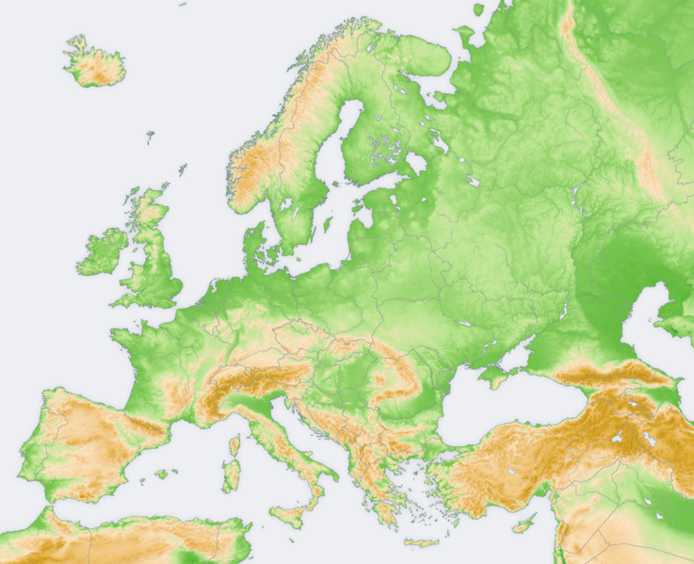](http://upload.wikimedia.org/wikipedia/commons/b/b7/Europe_topography_map.png)

*Source: text (font size 10, left-aligned)*